Maribor, July 2019

INFOSHEET 1

Project K1, Youth workers mobility
Innovative youth inclusion with creative industries
31th October – 5th November
Maribor, Slovenia

Information about the project

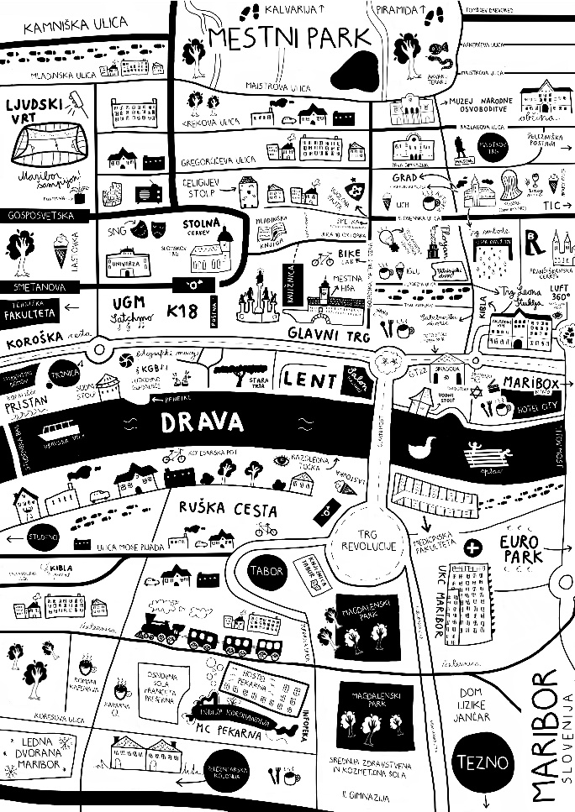
Mobility of youth workers (21+) – Training Course – Innovative youth inclusion with creative industries will take a place in Maribor (Slovenia) on the dates 31th October to 5th November 2019. Hiša! prepared the project in a wish to bring some new quality among the organizations who are involved with capacity building, participation, integration … through creative industries. Together we will share good practices, new approaches, discussing the previous problems, changes and the challenges within youth empowerment through creative industries. The activity is connected to researching sphere and will train youth workers/facilitators/actors/coordinators coming from organizations experienced in creative industries or willing to start their ventures in this field.

The training aims to investigate and broaden the youth empowerment to include more youth with fewer opportunities in to Erasmus plus projects, increasing the amount of high-quality execution and establishing partnerships, exchange of good practices and experiences related to E+ projects, volunteering, generating new project ideas, developing joint solutions, share the obstacles and doubts in the implementation of international projects in transcultural environment and increase the level of information about the methods of non-formal education.

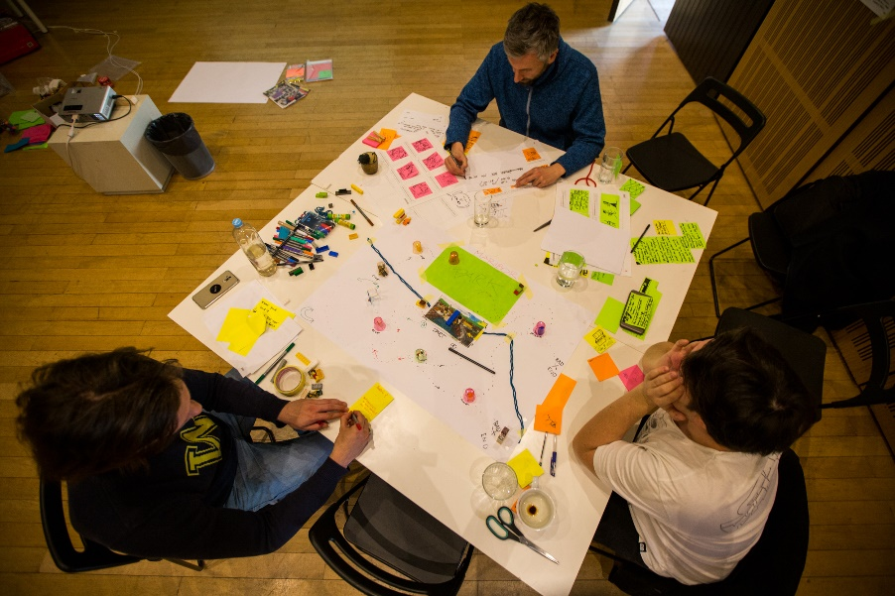
This project aims to recognize and improve youth work, non-formal learning and volunteering and link them to education systems and the labour market. It also supports regional and transnational non-formal learning mobility schemes to encourage the participation of youth in society.
By participating in the project, participants will be able to strengthen the capacity of their organizations, to internationalize their activities and to implement international projects with greater efficiency and effectiveness. For the purpose of promotion and dissemination they will create attractive flipbook, which will become an educational tool after the activity in each organisation/community.

Objectives

• To promote the programme Erasmus plus as an empowerment tool for youth,
• to investigate varieties of approaches within creative industries,
• to promote inter cultural learning and solidarity,
• to share good practices and gain new knowledge,
• to foster creative thinking and expression through art and new methods,
• to foster the value of inter cultural dialogue as a mean of promoting cooperation and collective spirit,
• to promote the idea of European citizenship.

Our partner organizations

Host organization
Hisa! društvo za ljudi in prostore so.p., Slovenia

Partners
Helden wider Willen e.V., Germany
ASSOCIATION OF ESTONIAN OPEN YOUTH CENTRES, Estonia
Udruga za razvoj umjetnosti, kulture i edukacije, Croatia
ASOCIATIA GEYC, Romania
UNIVERSITY OF AVEIRO ALUMNI ASSOCIATION, Portugal
ASOCIACION JUVENIL INTERCAMBIA, Spain

Participants: 7 countries x 2 youth workers (21+ -no limit) = 14 participants
Facilitators: 3 from Slovenia

Each organization sends 2 youth workers/facilitators/actors/coordinators.

Don’t forget to arrange EU insurance card, it’s for free: http://ec.europa.eu/social/main.jsp?catId=559. We will need the copy of it.

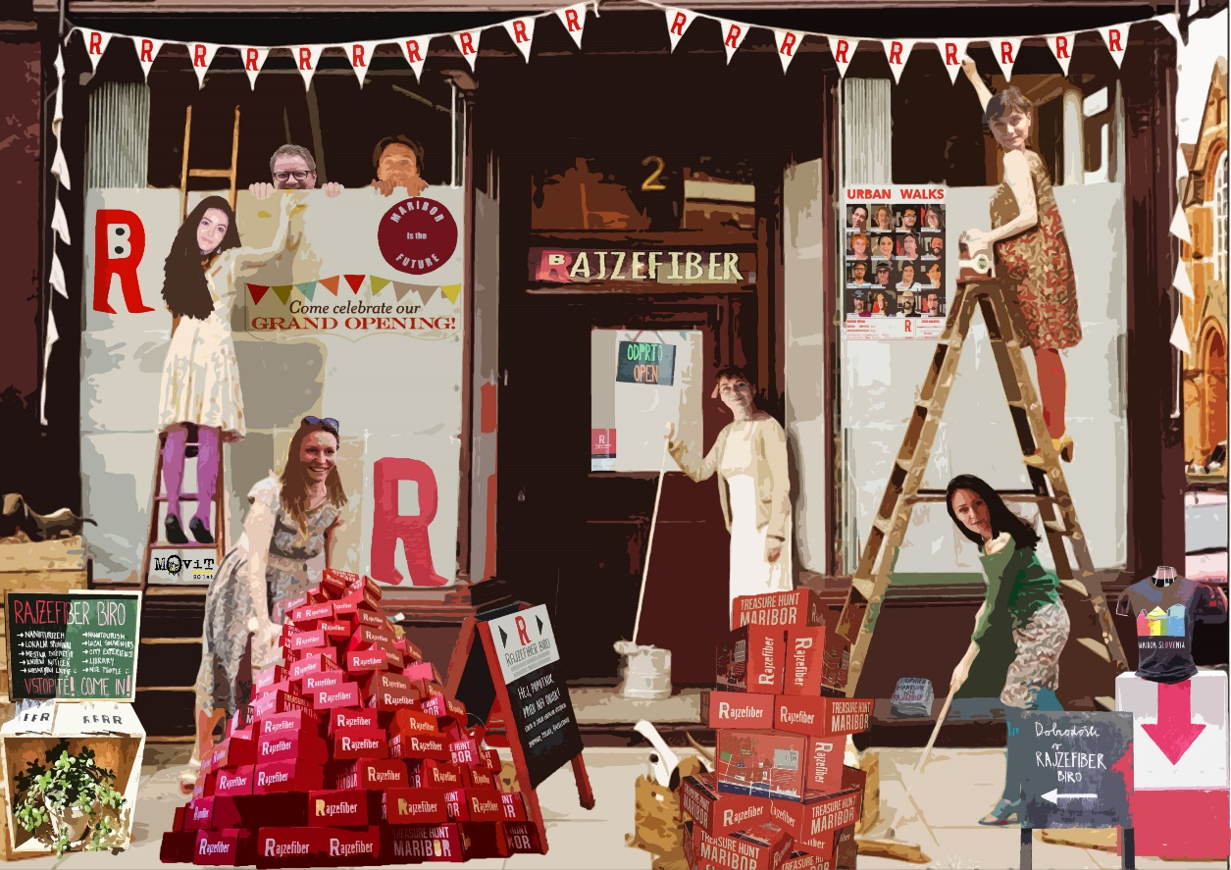
Hiša!’s team

Time line

August 2019

-Promotion of the project on the local /regional / national/ international level (through the whole project);
-To search for potential participants and to create a group of the participants;
-Facebook group for all the participants they connect before coming to Maribor (I will send you a link of the group and you can add yourself and participants in).

September – October 2019
-Preparation of the project group
Each organization should send us the info about the participants until 30th of September 2019 (to tomaz.podbevsek@gmail.com). We are going to send question form for the participants so that we will get basic info about them (health, age, other needs, motivation …).

It’s important that each organization gives info of the youth workers in time because the participants will have to do an assignment for the project until the beginning of the activity. Additional information about that will be send to you in September.
November 2019
-Activity implementation in Maribor (31th October – 5th November)
- Creating Flipbook - combining material and adding results
- PR
-Clipping
-Gathering papers, Transport reimbursement
November – December
-Finalisation of the Flipbook
-Presentation results of the project (all 7 European partners)
-Dissemination
-PR
-Clipping
-Preparation for the report
Costs

Društvo Hiša! and Erasmus+ program will cover all the expanses considering accommodation, food and program during the project. The participants or partner organizations will be also reimbursed the travel expenses for 2 participants:
Country | EUR/per person
Germany | 275€/person
Estonia | 275€/person
Spain | 275€/person
Croatia | 180€/person
Romania | 275€/person
Portugal | 360€/person
Slovenia | 0€/person

Each organization has to cheek with us before buying or confirming any reservations for tickets (send prices, mean of transport and dep/arr location in tomaz.podbevsek@gmail.com)!

Also we strongly suggest to you that you start to search for the tickets as soon as possible considering the prices get higher every day.

Travel info

To get to Maribor:

- Slovenian airline and airport: www.adria.si, Ljubljana airport – Letališče Jožeta Pučnika Ljubljana (approx. 150 km form Maribor)
- Near airports: Zagreb (Croatia; approx. 130 km from Maribor), Graz (Austria; approx. 60 km from Maribor), Trieste (Italy; approx. 250 km from Maribor), Venice (Italy, approx. 350 km from Maribor), Vienna (Austria; approx. 300 km from Maribor)
- To get from the airport to Maribor: local transport or if you don’t have good connections with local transport then you can use local provider of airport transport from Dajrenta.si (info@dajrentaj.si, http://dajrentaj.si/vrsta/prevozi/) or Goopti (http://www.goopti.si/index.php?lang=en)
- Slovenian train: www.slo-zeleznice.si

To get good prices always check local providers of the transport (bus, train … etc), who are usually the cheapest option of the transport.

About Maribor
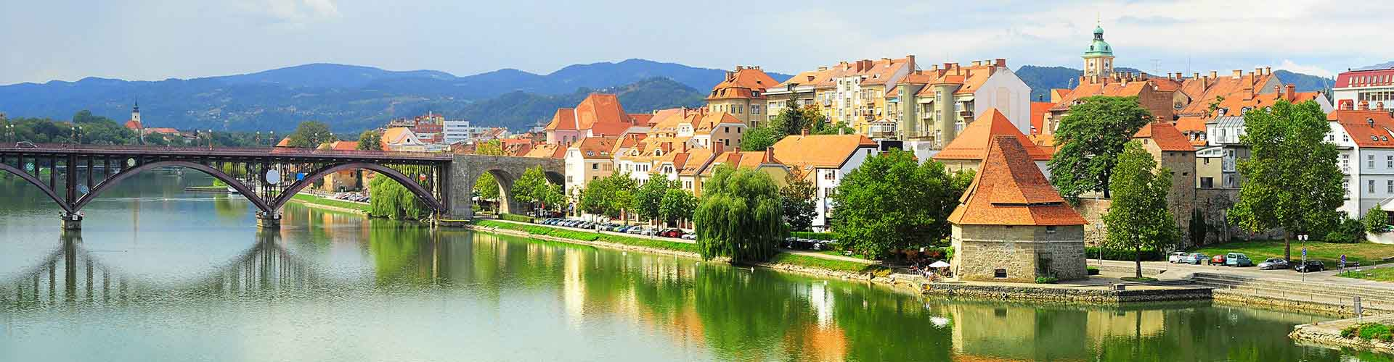
Maribor is the second largest Slovenian city. It’s small cozy with only a few more than 100 thousand inhabitants. It is the capital of Štajerska, which is one of the sunniest regions in the country. It is the city with the oldest wine tree in the world (over 400 years old), a charming old part of the town and Pohorje, which offers miles of slopes for skiing in winter and lines for downhill riders.
Maribor is knowned for culture, sport and wine. In autumn it hosts largest slovenian theater festival Borštnikovo srečanje. Minorite monastery in historic quarter of Lent hosts puppet theater.
In 2018 Maribor was awarded with title European City of Sport. Mountaineering, skiing and cycling are very popular recreational activities.
More: https://www.slovenia.info/en/places-to-go/cities/maribor-and-pohorje

Regards
Tomaž Podbevšek
Društvo Hiša!
Orožnova 7, 2000 Maribor
+386 31 213 160

